Year 10 Semester One – Paper B

Mathematics Examination
Part One: NO Calculators Allowed

Name ________________________________ Teacher ________________________

TIME ALLOWED FOR THIS PAPER
Reading time before commencing : 5 minutes.
Working time for paper : 50 minutes.

MATERIAL REQUIRED /RECOMMENDED FOR THIS PAPER

TO BE PROVIDED BY THE SUPERVISOR
This question paper comprising 6 questions.
Attempt ALL questions.
Total marks for the paper : 75
Answers are to be written on this test booklet in the spaces provided.

TO BE PROVIDED BY THE CANDIDATE
Pens, pencils, eraser.
One (1) A4 page of notes (handwritten, photocopied or typed on both sides) that may be either personally or commercially produced.

INSTRUCTIONS TO CANDIDATES
Write all answers in the spaces provided - if working is completed on extra pages, indicate on the original question that your working continues elsewhere.
If extra paper is needed in any section, please ask one of the supervisors.

Show all working clearly, in sufficient detail to allow your answers to be checked readily and for marks to be awarded for reasoning. No marks will be awarded to incorrect answers without supporting reasoning.

Question | Possible Marks | Your Mark
1 | 4
2 | 14
3 | 11
4 | 19
5 | 10
6 | 17
Total | 75
Question 1 [4 marks]

a) The mean radius of the earth is 6 371 000 m. Express this measurement using scientific notation.

[1]

b) The mean radius of the moon is 1.738 x 10⁶ metres. Write 1.738 x 10⁶ metres as a number without scientific notation.

[1]

c) The diameter of a single human hair is approximately 0.000 071 m. Express 0.000 071 in scientific notation.

[1]

d) A nanometre is 10⁻⁹ metres. Express this in decimal form.

[1]

Question 2 [14 marks]

a) Evaluate the following. Express your answer with positive indices.
(i) 2³ (ii) 2⁻² (iii) 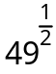

[3]

b) Express 81² as a power of 3.

[3]

c) Simplify and express with positive indices.

(i) 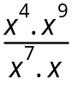 (ii) (2m³n)⁶

(iii) (x ⁵)³.(y ⁶)⁴

[6]

d) Simplify 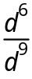 . Express your answer:
i) with positive indices

(ii) without fractions

[2]
Question 3 [11 marks]

a) Consider the following graphs of lines.
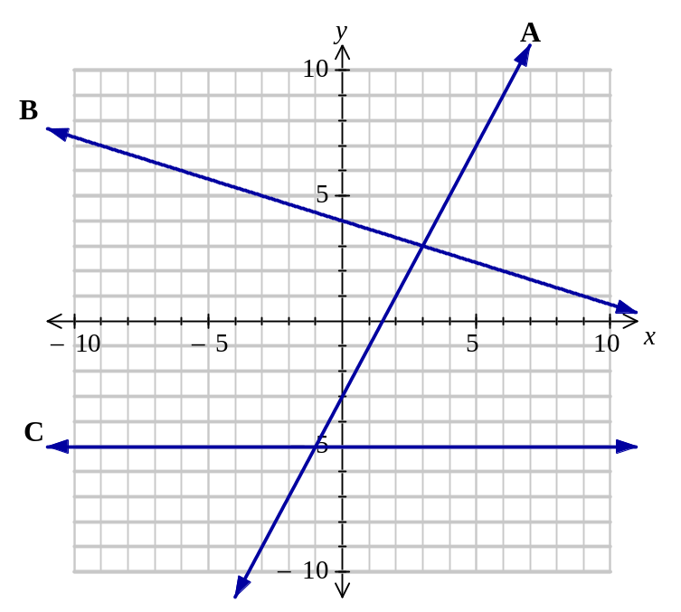

Complete the following table for each line.

Line | y-intercept in form (a, b) | Gradient | Equation
A
B
C

[6]
b) State the gradient and y-intercept of the following:

(i) y = 3 – 4x (ii) 6x – 3y = –21

[5]
Question 4 [19 marks]

a) Solve the following equations
(i) 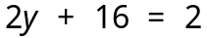 (ii) 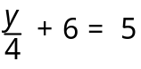

(iii) 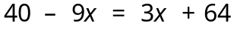 (iv) 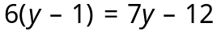

[9]

b) The formula that can be used to find the volume, V cm³ of a rectangular prism is V = lwh.
(i) Find V when l = 8, w = 6, h = 2.

[2]

(ii) Transpose the equation to make w the subject. (ie w =)

[2]

(iii) Hence or otherwise, find w when V = 240, l = 3 and h = 10.

[2]
c) Four times a number increased by 45 equals seven times the number.
(i) Let the number be n. Write an equation that matches the situation.

(ii) Solve your equation to find the number.

[4]
Question 5 [10 marks]

a) State the type of relationship (linear, quadratic or neither) for each of the tables of values below. For those that you identify to be linear or quadratic, state the rule that shows the relationship between x and y.
(i)
x | 0 | 1 | 2 | 3 | 4 | 5
y | 3 | 4 | 7 | 12 | 19 | 28

(ii)
x | 0 | 1 | 2 | 3 | 4 | 5
y | –1 | 1 | 3 | 5 | 7 | 9

(iii)
x | 1 | 2 | 3 | 4 | 5 | 6
y | 6 | 3 | 2 | 1.5 | 1.2 | 1

(iv)
x | 0 | 1 | 2 | 3 | 4 | 5
y | 25 | 22 | 19 | 16 | 13 | 10

(v)
x | 0 | 1 | 2 | 3 | 4 | 5
y | 0 | 3 | 12 | 27 | 48 | 75

(vi)
x | 0 | 1 | 2 | 3 | 4 | 5
y | 1 | 3 | 9 | 27 | 81 | 243

[10]

Question 6 [17 marks]

a) Solve these equations.

(i) (x – 3) (2x + 1) = 0 (ii) a² – 49 = 0

(iii) 3r² – 21r = 0 (iv) x² – x = 6

[12]

b) The length of a rectangular lot is 3 metres more than its width.

(i) Let the width be w. Draw a diagram and label the length and width in terms of w.

(ii) Find the length and width of the rectangular lot if the area is 40m².

[5]

